Excel curve fitting Lesson

AUTHOR: Kyle Kendrick
DATE LESSON TO BE TAUGHT:
GRADE LEVEL: Algebra

TEKS:

CONCEPT(S) How to use excel to find a line of best fit.

OBJECTIVES (LEARNER OUTCOMES): The student will be able to
-Use Excel to find a line of best fit
-Determine the strength of a fit based on the value of r²

MATERIALS LIST and ADVANCED PREPARATIONS:
A computer for every 2 or 3 students.

SUPPLEMENTARY MATERIALS:
Handout (p.4)

Engagement (10 min)

What the Teacher Will Do | Eliciting Questions | Student Responses
Review exponential growth.  Good today we will learn how to model real world data. | What can an exponential function represent?  Yesterday we did a lesson with Skeeter’s how did they grow? And how would that compare to a real population (for example birds). | Population growth.  Both can be exponential but the skeeters were perfectly exponential.

Exploration (30 min)

What the Teacher Will Do | Eliciting Questions | Student Responses
Demonstrate how to use excel to fit trend lines to data sets.  Pass out activity. |  | Students will complete the activity.

Explanation (5 min)

What the Teacher Will Do | Eliciting Questions | Student Responses
 | What r² represent?  When we use real life data will we every get r²=1? | How well the line fits to the data.  No because real life data isn’t going to be completely perfect. We could get really close to 1 to show a strong relationship but it would never equal 1.

Evaluation (10 min)

What the Teacher Will Do | Eliciting Questions | Student Responses
Give students the following data  The table below if the height of a model rocket under the influence of gravity only (after 2 seconds of thrust) at different times t (sec). | 1. Make a scatter plot in excel of the data.  2. What type of function do you think would fit this data?  3. Find the line of best fit write the formula below and record the r² value.
  t (sec) | h (ft)
  2 | 166.2
  3 | 215.7
  4 | 234.5
  5 | 219.6
  6 | 174.0
  7 | 96.1

Use the following data sets and follow the instructions

1. Create a chart of the following data do you have any predictions what type of relation ship this is?
Hour | Distance
1 | 3.5
2 | 5.5
3 | 10
4 | 13
5 | 16
6 | 20

2. Add a trend line selecting the line you think will be the best fit. Be sure to select the option to show R² Value.

3. Look at the following picture
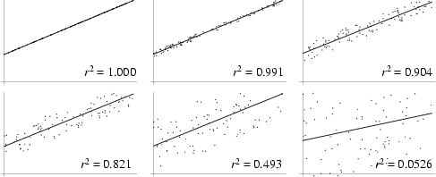
When is r²=1?

What happens to the data points as r² becomes smaller?

What do you think r² represents?

4. Based on your value for r² how good is your fit?

5. Now make a chart for the following data set. What type of line do you think will fit best?
Day | Pop. Size
1 | 2
3 | 3
10 | 34
12 | 62
15 | 185
6. Try a linear fit. What is the value of r²? Try a quadratic fit. Try an exponential fit. Which line is the best fit? How do you know?

